✦ LAB REPORT ✦
UNIVERSITY OF WAH · DEPARTMENT OF COMPUTER SCIENCE
Web Application
Development
CS-371 · PRE-DJANGO
LAB 04
Introduction to Bootstrap, Responsive Design and Utility Classes
five tasks, a lot of <div> tags, and one very responsive me.
THIS REPORT BELONGS TO
NAME FAIZA AROOJ

ROLL NO. UW-24-AI-BS-014

SECTION AI 5TH

SUBMISSION DATE 27/10/2026

1 | TASK 01  GRID PRACTICE  twelve columns, infinite possibilities

WHAT I DID
For my first task, I wanted to really feel how Bootstrap's 12-part grid behaves, so I built the six practice rows inside a container and picked column classes to match the target at both screen sizes. I started with the phone layout (col-12) and then layered md and lg classes on top, which made it much easier to predict what would wrap. I also tucked a nested row inside one column and checked that it gets its own fresh 12 parts. Resizing the browser back and forth was weirdly satisfying.
REQUIREMENTS COVERED
✔ Structure built as container › row › col, with each box labelled by its own classes
✔ Mobile-first classes such as col-12 col-md-6 and col-12 col-md-6 col-lg-4
✔ Uneven splits (col-md-3 + col-md-9) and equal splits that sum to 12 on a laptop
✔ A nested row inside a column, plus col-6 col-md-3 boxes (2 per line on phones, 4 on md and up)
✔ Layout checked at laptop width and at phone width against the target
<!doctype html>
<html lang="en">
<head>
<meta charset="utf-8">
<meta name="viewport" content="width=device-width, initial-scale=1">
<title>Lab 04 - Task 1: Grid Practice</title>
<link href="css/bootstrap.min.css" rel="stylesheet">
</head>
<body>
<main class="container my-4">
<h1 class="h2 mb-4">Grid Practice</h1>

<div class="row">
<div class="col-12">
<div class="border rounded bg-light text-center p-3 mb-3">col-12</div>
</div>
</div>

<div class="row">
<div class="col-12 col-md-6">
<div class="border rounded bg-light text-center p-3 mb-3">col-12 col-md-6</div>
</div>
<div class="col-12 col-md-6">
<div class="border rounded bg-light text-center p-3 mb-3">col-12 col-md-6</div>
</div>
</div>

<div class="row">
<div class="col-12 col-md-6 col-lg-4">
<div class="border rounded bg-light text-center p-3 mb-3">col-12 col-md-6 col-lg-4</div>
</div>
<div class="col-12 col-md-6 col-lg-4">
<div class="border rounded bg-light text-center p-3 mb-3">col-12 col-md-6 col-lg-4</div>
</div>
<div class="col-12 col-md-6 col-lg-4">
<div class="border rounded bg-light text-center p-3 mb-3">col-12 col-md-6 col-lg-4</div>
</div>
</div>

<div class="row">
<div class="col-12 col-md-3">
<div class="border rounded bg-light text-center p-3 mb-3">col-12 col-md-3</div>
</div>
<div class="col-12 col-md-9">
<div class="border rounded bg-light text-center p-3 mb-3">col-12 col-md-9</div>
</div>
</div>

<div class="row">
<div class="col-12">
<div class="row">
<div class="col-6 col-md-3">
<div class="border rounded bg-light text-center p-3 mb-3">col-6 col-md-3</div>
</div>
<div class="col-6 col-md-3">
<div class="border rounded bg-light text-center p-3 mb-3">col-6 col-md-3</div>
</div>
<div class="col-6 col-md-3">
<div class="border rounded bg-light text-center p-3 mb-3">col-6 col-md-3</div>
</div>
<div class="col-6 col-md-3">
<div class="border rounded bg-light text-center p-3 mb-3">col-6 col-md-3</div>
</div>
</div>
</div>
</div>
</main>
<script src="js/bootstrap.bundle.min.js"></script>
</body>
</html>

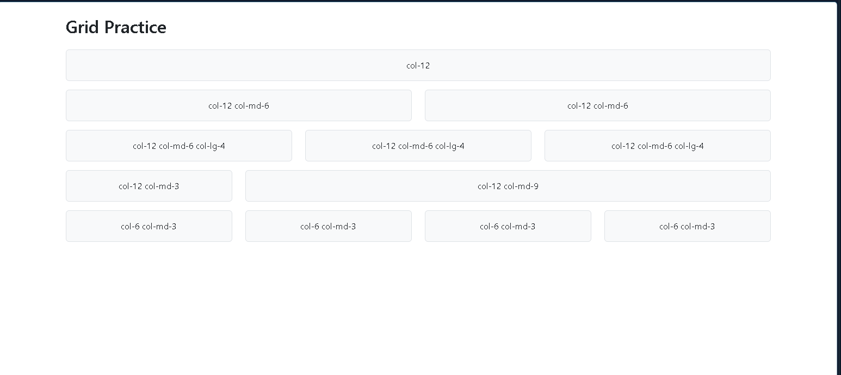

2 | TASK 02  NOTICE BOARD  a little corner of the internet for CS Society

WHAT I DID
For my second task, I recreated the CS Society notice board using nothing but Bootstrap utility classes, with zero lines of my own CSS. A blue banner with centred white text sits on top, three notice cards (Git workshop, fee deadline, sports week) share the row, and a small footer strip uses d-flex to push its two pieces of text to opposite ends. I used colour with meaning: the fee deadline gets the red danger border because it is the one you really do not want to miss.
REQUIREMENTS COVERED
✔ Banner built with bg-primary, text-white, p-4, rounded and text-center
✔ Three cards using border, rounded, shadow and p-3, in a container › row › col layout
✔ Colour utilities for emphasis: text-primary, text-danger with border-danger, text-success
✔ Small muted dates with small and text-body-secondary
✔ Footer with d-flex, justify-content-between and align-items-center
✔ No custom CSS file or <style> block anywhere
<!doctype html>
<html lang="en">
<head>
<meta charset="utf-8">
<meta name="viewport" content="width=device-width, initial-scale=1">
<title>Lab 04 - Task 2: CS Society Notice Board</title>
<link href="css/bootstrap.min.css" rel="stylesheet">
</head>
<body>
<main class="container my-4 p-4 border">
<header class="bg-primary text-white text-center rounded p-4 mb-3">
<h1 class="h2 fw-bold mb-1">CS Society Notice Board</h1>
<p class="lead text-white-50 mb-0">News for every Computer Science student</p>
</header>

<div class="row g-3">
<div class="col-12 col-md-4">
<section class="h-100 border rounded shadow-sm p-3">
<h2 class="h6 text-primary mb-1">Workshop on Git</h2>
<p class="small text-secondary mb-2">22 October 2026</p>
<p class="mb-0">Bring your laptop. Lab 3, 10 am to 12 pm.</p>
</section>
</div>
<div class="col-12 col-md-4">
<section class="h-100 border border-danger rounded shadow-sm p-3">
<h2 class="h6 text-danger mb-1">Fee Deadline</h2>
<p class="small text-secondary mb-2">25 October 2026</p>
<p class="mb-0">Pay the semester fee before 5 pm to avoid a fine.</p>
</section>
</div>
<div class="col-12 col-md-4">
<section class="h-100 border rounded shadow-sm p-3">
<h2 class="h6 text-success mb-1">Sports Week</h2>
<p class="small text-secondary mb-2">2 November 2026</p>
<p class="mb-0">Cricket and football trials start on Monday.</p>
</section>
</div>
</div>

<footer class="d-flex justify-content-between align-items-center bg-light border rounded p-3 mt-3">
<span class="fw-bold small">Updated weekly</span>
<span class="text-secondary small text-uppercase">Student Affairs Office</span>
</footer>
</main>
<script src="js/bootstrap.bundle.min.js"></script>
</body>
</html>

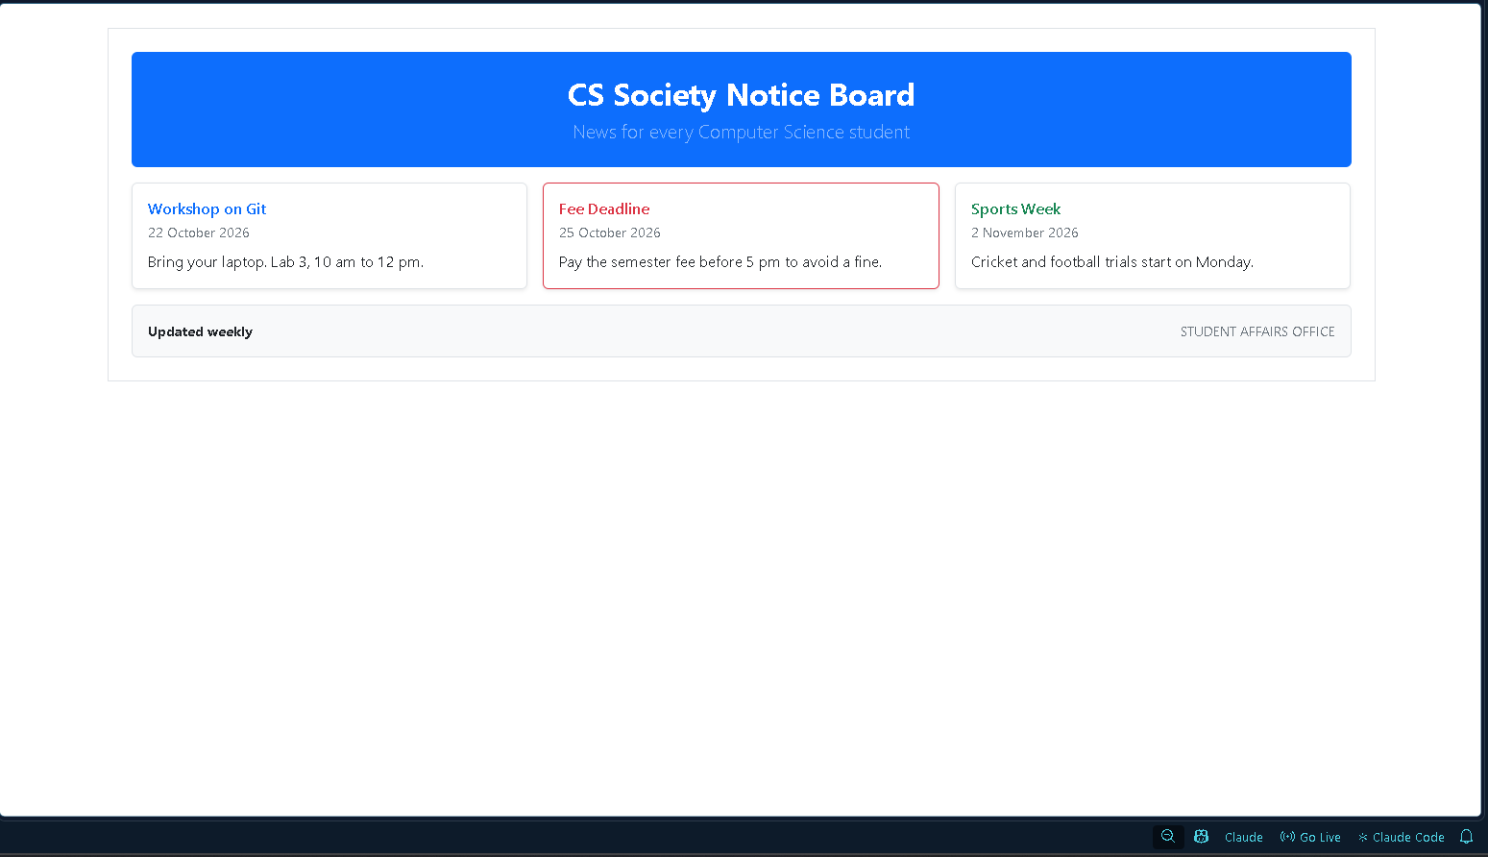

3 | TASK 03  RESPONSIVE CV  my Lab 1 CV, all grown up

WHAT I DID
For my third task, I rebuilt my Lab 1 CV with my own details, this time using only Bootstrap classes. On a laptop it is a two-column layout with a sidebar for contact, skills and languages, and a wider main column for about me, education and projects. On a phone, both columns stack into one. The header has a blue banner with a round profile picture, and the education table and project list got their Bootstrap styling too. It was the first time my CV actually looked good on my phone.
REQUIREMENTS COVERED
✔ Two columns on laptops, one column on phones (col-12 col-md-4 and col-12 col-md-8)
✔ Blue header banner with my name, degree and email badge
✔ Profile picture with img-fluid and rounded-circle
✔ Education table with table, table-sm and a dark header (table-dark)
✔ Projects as a list with list-unstyled, plus spacing and colour utilities throughout
✔ No CSS of my own, just Bootstrap classes
<!doctype html>
<html lang="en">
<head>
<meta charset="utf-8">
<meta name="viewport" content="width=device-width, initial-scale=1">
<title>Lab 04 - Task 3: My CV</title>
<link href="css/bootstrap.min.css" rel="stylesheet">
</head>
<body>
<main class="container my-4">
<article class="row g-0 border rounded shadow-sm mx-auto">
<header class="col-12 bg-primary text-white p-3">
<div class="row align-items-center">
<div class="col">
<h1 class="h3 fw-bold mb-1">Your Name</h1>
<p class="mb-2">BS Artificial Intelligence, University of Wah</p>
<span class="badge text-bg-light text-dark">aroojfaiza7865@gmail.com</span>
</div>
<div class="col-auto">
<svg class="rounded-circle border border-2 border-white" width="72" height="72" viewBox="0 0 72 72" role="img" aria-label="Profile picture placeholder">
<rect width="72" height="72" fill="#e9d8f4"/>
<circle cx="36" cy="25" r="13" fill="#e6c6a8"/>
<path d="M12 72c2-17 11-25 24-25s22 8 24 25" fill="#70408b"/>
</svg>
</div>
</div>
</header>

<aside class="col-12 col-md-4 bg-light p-3">
<section class="mb-3">
<h2 class="h6 text-primary text-uppercase border-bottom border-primary pb-1">Contact</h2>
<p class="small mb-1">Your City, Pakistan</p>
<p class="small mb-0">0300-1234567</p>
</section>
<section class="mb-3">
<h2 class="h6 text-primary text-uppercase border-bottom border-primary pb-1">Skills</h2>
<p class="small mb-0">HTML · CSS · Bootstrap · Python · C++ · Git</p>
</section>
<section>
<h2 class="h6 text-primary text-uppercase border-bottom border-primary pb-1">Languages</h2>
<ul class="list-unstyled small mb-0">
<li>Web Development</li>
<li>Operating Systems</li>
<li>Database Management</li>
</ul>
</section>
</aside>

<div class="col-12 col-md-8 p-3">
<section class="mb-3">
<h2 class="h6 text-primary text-uppercase border-bottom border-primary pb-1">About Me</h2>
<p class="small mb-0">AI student who enjoys building websites and solving problems with code.</p>
</section>
<section class="mb-3">
<h2 class="h6 text-primary text-uppercase border-bottom border-primary pb-1">Education</h2>
<div class="table-responsive">
<table class="table table-sm table-bordered small mb-0">
<thead class="table-dark">
<tr><th>Degree</th><th>Institute</th><th>Years</th></tr>
</thead>
<tbody>
<tr><td>BS Artificial Intelligence</td><td>University of Wah</td><td>2024-2028</td></tr>
<tr><td>FSc Pre-Medical</td><td>Mashal Degree College</td><td>2022-2024</td></tr>
</tbody>
</table>
</div>
</section>
<section>
<h2 class="h6 text-primary text-uppercase border-bottom border-primary pb-1">Projects</h2>
<ul class="small mb-0">
<li><strong>Library Website:</strong> A multi-page site in HTML and CSS.</li>
<li><strong>Campus News Board:</strong> A Bootstrap page for campus notices.</li>
<li><strong>Notice Board:</strong> This Lab 04 Bootstrap page.</li>
</ul>
</section>
</div>

<footer class="col-12 border-top text-center text-secondary small p-2">Last updated October 2026</footer>
</article>
</main>
<script src="js/bootstrap.bundle.min.js"></script>
</body>
</html>

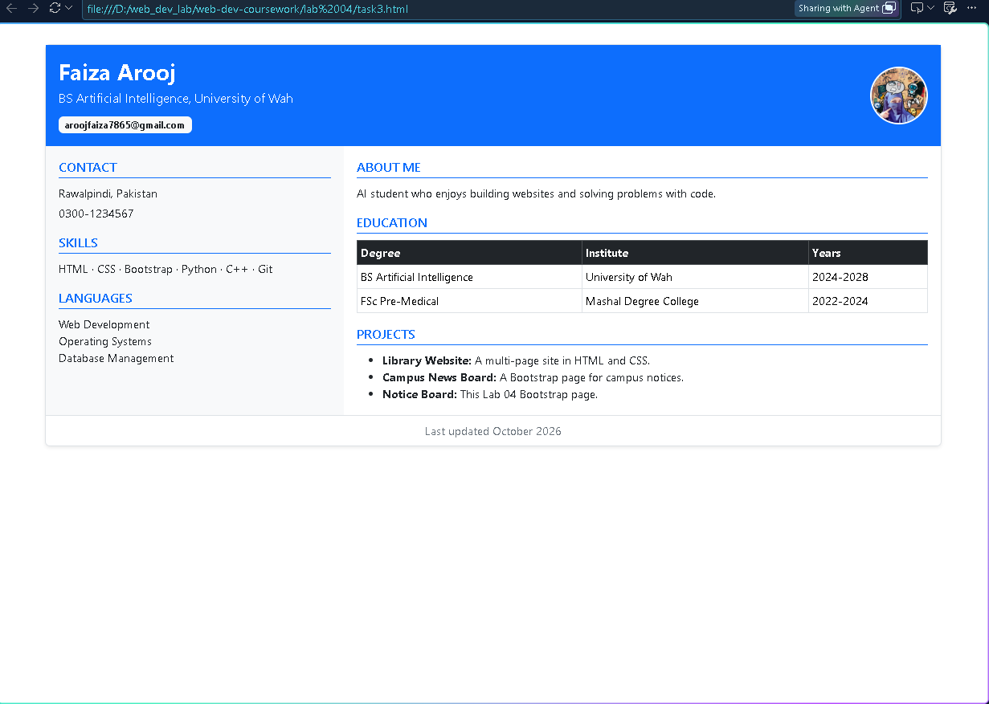

4 | TASK 04  RESULTS TABLE  numbers, stripes and one highlighted star

WHAT I DID
For my fourth task, I built the mid-term results table with Bootstrap's table classes. The base table class does the heavy lifting, and I added striped, hover and bordered styles, a dark header, and table-success on Sana Malik's row since she scored the highest. The two ?? cells had to be worked out by hand, so I added the five marks first and then divided by the number of students.
REQUIREMENTS COVERED
✔ Base table class with table-striped, table-hover and table-bordered
✔ table-dark applied to the <thead> only, for a dark header
✔ Top student's row (Sana Malik, 92) highlighted with table-success
✔ Total and Class average rows added, with the two ?? values worked out by hand
✔ Small muted note under the table: marks out of 100
✎ Sum: 88+76+92+64+81. Total = 401 · Class average = 401 ÷ 5 = 80.2

<!doctype html>
<html lang="en">
<head>
<meta charset="utf-8">
<meta name="viewport" content="width=device-width, initial-scale=1">
<title>Lab 04 - Task 4: Mid-term Results</title>
<link href="css/bootstrap.min.css" rel="stylesheet">
</head>
<body>
<main class="container my-4">
<section class="border p-4">
<h1 class="h3 text-center mb-3">Web Application Development: Mid-term Results</h1>
<div class="table-responsive">
<table class="table table-striped table-bordered table-hover align-middle mb-2">
<thead class="table-dark">
<tr>
<th scope="col">#</th>
<th scope="col">Name</th>
<th scope="col">Roll No</th>
<th scope="col">Marks</th>
<th scope="col">Grade</th>
</tr>
</thead>
<tbody>
<tr><th scope="row">1</th><td>Ayesha Khan</td><td>FA24-BCS-017</td><td>88</td><td>A</td></tr>
<tr><th scope="row">2</th><td>Bilal Ahmed</td><td>FA24-BCS-022</td><td>76</td><td>B</td></tr>
<tr class="table-success"><th scope="row">3</th><td>Sana Malik</td><td>FA24-BCS-031</td><td>92</td><td>A</td></tr>
<tr><th scope="row">4</th><td>Hamza Ali</td><td>FA24-BCS-040</td><td>64</td><td>C</td></tr>
<tr><th scope="row">5</th><td>Zainab Noor</td><td>FA24-BCS-045</td><td>81</td><td>A</td></tr>
<tr><th colspan="3" scope="row">Total</th><td>401</td><td></td></tr>
<tr><th colspan="3" scope="row">Class average</th><td>80.2</td><td></td></tr>
</tbody>
</table>
</div>
<p class="text-secondary mb-0">Marks out of 100. The top student is highlighted.</p>
</section>
</main>
<script src="js/bootstrap.bundle.min.js"></script>
</body>
</html>

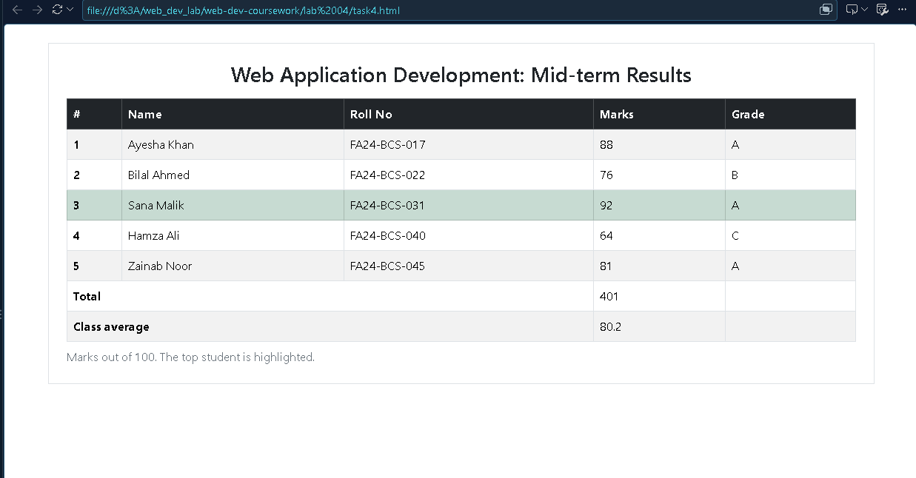

5 | TASK 05  CAMPUS PHOTOS  pictures that actually fit on a phone

WHAT I DID
For my last task, I laid out the campus photo gallery so it shows two pictures per row on phones and three per row from md up, using col-6 col-md-4 with img-fluid on every image so nothing overflows. Below it, the Photo Team section pairs each person with their picture using d-flex and align-items-center: one portrait is a perfect circle (rounded-circle) and the other is framed (img-thumbnail). Square source pictures made the circle look right.
REQUIREMENTS COVERED
✔ Gallery grid with col-6 col-md-4 and a g-* gap between pictures
✔ img-fluid and rounded on every photo, with a small caption underneath
✔ Photo Team entries aligned with d-flex, align-items-center and gap utilities
✔ One round picture (rounded-circle) and one thumbnail picture (img-thumbnail)
✔ Resized the browser to confirm 2 per row on phones and 3 per row on tablets and up
<!doctype html>
<html lang="en">
<head>
<meta charset="utf-8">
<meta name="viewport" content="width=device-width, initial-scale=1">
<title>Lab 04 - Task 5: Campus Photos</title>
<link href="css/bootstrap.min.css" rel="stylesheet">
</head>
<body>
<main class="container my-4">
<section class="border p-3 p-md-4">
<h1 class="h3 text-center mb-3">Campus Photos</h1>
<div class="row g-3 text-center">
<figure class="col-6 col-md-4 mb-0">
<img class="img-fluid rounded shadow-sm" src="maingate.jfif" alt="University main gate" loading="lazy">
<figcaption class="small mt-1">Main gate</figcaption>
</figure>
<figure class="col-6 col-md-4 mb-0">
<img class="img-fluid rounded shadow-sm" src="library.jfif" alt="University library" loading="lazy">
<figcaption class="small mt-1">Library</figcaption>
</figure>
<figure class="col-6 col-md-4 mb-0">
<img class="img-fluid rounded shadow-sm" src="photos/robotics-lab.jpg" alt="Student working in an engineering lab" loading="lazy">
<figcaption class="small mt-1">Engineering lab</figcaption>
</figure>
<figure class="col-6 col-md-4 mb-0">
<img class="img-fluid rounded shadow-sm" src="labs.jpg" alt="Computer lab with students at their workstations" loading="lazy">
<figcaption class="small mt-1">Computer lab</figcaption>
</figure>
<figure class="col-6 col-md-4 mb-0">
<img class="img-fluid rounded shadow-sm" src="photos/lake-sunset.jpg" alt="Sunset over mountain ranges" loading="lazy">
<figcaption class="small mt-1">Mountain sunset</figcaption>
</figure>
<figure class="col-6 col-md-4 mb-0">
<img class="img-fluid rounded shadow-sm" src="graduation.jfif" alt="Graduation day" loading="lazy">
<figcaption class="small mt-1">Graduation day</figcaption>
</figure>
</div>

<h2 class="h4 mt-4 mb-3">Photo Team</h2>
<div class="row g-3">
<div class="col-12 col-md-6">
<div class="d-flex align-items-center gap-3">
<img class="rounded-circle" src="photos/team-lead.jpg" width="72" height="72" alt="Photo team lead portrait" loading="lazy">
<div>
<h3 class="h6 mb-1">Ayesha Khan</h3>
<p class="small text-secondary mb-0">Team lead, took most of the campus photos.</p>
</div>
</div>
</div>
<div class="col-12 col-md-6">
<div class="d-flex align-items-center gap-3">
<img class="img-thumbnail" src="photos/team-editor.jpg" width="56" height="72" alt="Photo team editor portrait" loading="lazy">
<div>
<h3 class="h6 mb-1">Bilal Ahmed</h3>
<p class="small text-secondary mb-0">Edited the pictures for the website.</p>
</div>
</div>
</div>
</div>
</section>
</main>
<script src="js/bootstrap.bundle.min.js"></script>
</body>
</html>

